**Modelling Lymphatic Filariasis Transmission in American Samoa: Long-Term Population Dynamics and Spatially Heterogeneous Risks**

1. **Results**

**Population dynamics**

**Employment and school attendance**

With the labor force participation rates (LFPRs) by age groups1 and the 2010 census population2, the overall LFPR of males (females) aged 15-69 was 56.5% (36.3%) in American Samoa. The total employment was estimated to be approximately 16,000, which was quite close to the statistics (16,616).

Here are the simulation outputs (year, total students, elementary students, high students, college students):

*1.***2010: 16787 7586 7326 1875**

*2.***2011: 16531 7448 7101 1982**

*3.***2012: 16207 7312 6897 1998**

The total number of students is close to the data in the statistical yearbook. In 2010, the figure is 17,885. And the college students are also approximately to the real figure (2,193). However, the ratio of elementary students and secondary students is quite different from the data. In our simulation, the ratio is around 1:1. However, in the statistical yearbook, it is 2:1 (10,673 elementary and 4,591 secondary).

**Commuting networks**

1. **Methods and Materials**

**Population dynamics**

The population generation algorithm is based on the previous work on synthetic population in American Samoa3. Improvements have been provided to make the algorithm more realistic and flexible. Instead of building households based on individuals in the synthetic population, households were generated based on family units in this study. A family unit is composed of a couple or a single adult, with possible underage children (under 15 years) and unmarried adult children. The large household size indicates that a household is likely to be composed of multiple family units in American Samoa. The approach allows optimizing the family and household structure for the synthetic population. A second improvement is related to the age structure of the population. Instead of assuming uniformly distributed individuals in each age group, the new algorithm resorted to kernel smoothed method to get more realistic population structure, with smooth transition between individual age. Furthermore, the household size was assumed to follow the zero-truncated Poisson (ZTP) distribution. The ZTP parameter was determined with the maximum-likelihood estimation method based on the survey data. The application of ZTP makes the synthetic population generation algorithm more feasible for other census population with limited household details.

As in the previous work3, the population is also characterized by major dynamic processes including population renewal (birth/death), couple formation and separation, and migration. The fertility rates of females by age groups were based on the projections from the United States Census Bureau4. The mortality rates of males and females were based on the life table in the statistical yearbook2, assuming an annual mortality improvement of 1%. The existing couple separated with a fixed small probability each year. The female and any underage children (below 15 yrs.) were assumed to move to a new household in case of a divorce. The major change is related to individual movement between households. A large household with multiple family units might divide into two smaller households with a probability depending on both the household size and household stability. Each year, a household experiencing an expansion in household size that year with members more than the observed average household size ( $λ=Λ_{h}$ from the survey data) was deemed to be unstable. An unstable household was able to fracture into two households in accordance with a given probability. To determine the fracture probability, a threshold ($Θ_{h}$) was defined as: $Θ_{h}=min\left\{N: ∃k<N. ZTP\left(N\right)≤ZTP\left(k\right)×ZTP\left(N-k\right)\right\}$, where $ZTP\left(k\right)={λ^{k}}/{((e^{λ}-1) k!)}$. The household fracture probability ($p_{f}$) was defined as: $p_{f}=0.2$, $Λ_{h}≤s_{h}<Θ_{h}$; $p_{f}=0.8$, $s_{h}≥Θ_{h}$. If the size of the largest family unit of the household was within a reasonable range ($1/3≤{max\left\{s_{u}\right\}}/{s_{h}}<2/3$), the largest family unit was assumed to move to a new household in case the household fractured at the probability $p_{f}$.

**Employment and school attendance**

The cultural relationship in the Samoan islands implies many similarities between American Samoa and Samoa. As the labor force participation rates (LFPRs) by age groups of American Samoa were not available, the LFPRs1 of Samoa were used as an alternative. However, American Samoa does have stronger policy on ancestral land rights and less population on agriculture. Therefore, instead of the overall LFPRs of Samoa, the LFPRs of urban areas in Samoa (Fig 1) were used.

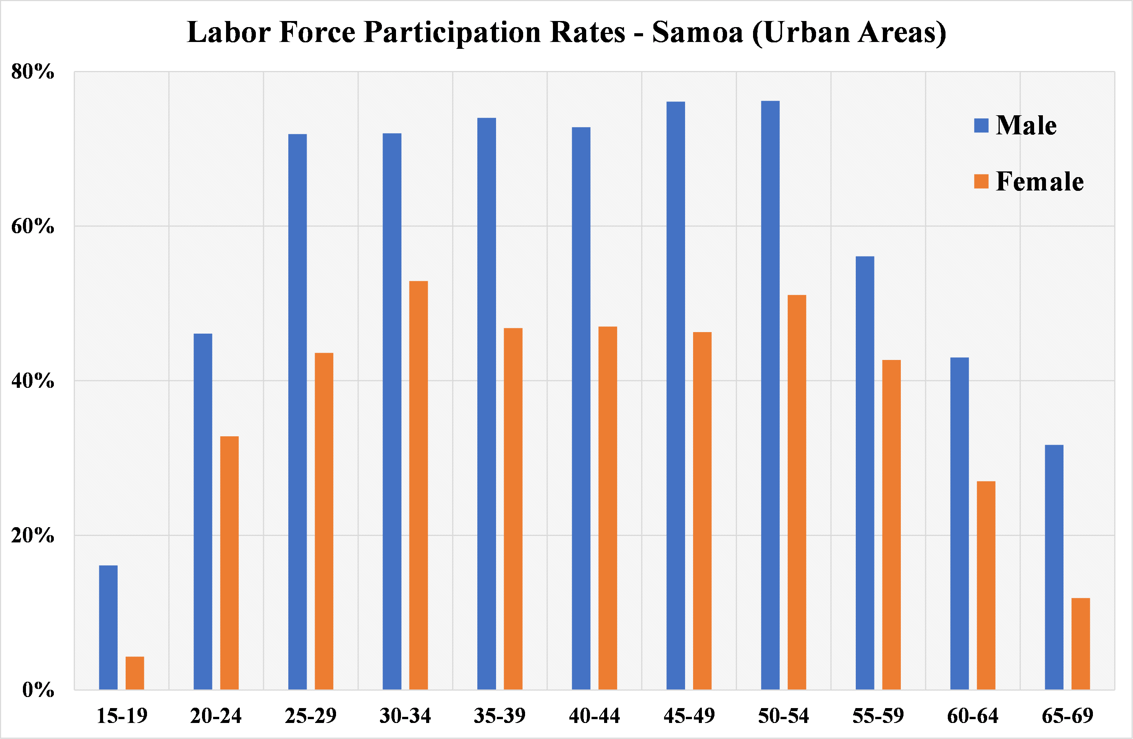

Fig 1. Labor force participation rates by gender and age groups

For any individual $i$ with age $a$, let $p_{a}$ be the LFPR at $a$ and $ϕ_{a}$ be the employment status at $a$ ( $ϕ_{a}=1$ employed, otherwise 0), then the conditional probability of individual $i$ being employed at age $a$ given the employment status at age $a-1$ ($p\left(ϕ_{a} | ϕ_{a-1}\right)$) is defined by:

* if $p_{a}>p_{a-1}$: $p\left(ϕ_{a}=1 | ϕ_{a-1}=1\right)=1$, $p\left(ϕ_{a}=1 | ϕ_{a-1}=0\right)={(p_{a}-p_{a-1})}/{(1-p_{a-1})}$;
* if $p_{a}<p_{a-1}$: $p\left(ϕ_{a}=0 | ϕ_{a-1}=0\right)=1$, $p\left(ϕ_{a}=0 | ϕ_{a-1}=1\right)={(p_{a-1}-p_{a})}/{(1-p_{a-1})}$.

The schooling system provides compulsory elementary (Grade 1 to 8) and secondary (Grade 9-12) school education in American Samoa. However, there is still a small number of secondary school dropouts, who are able to participate into the labor force. The American Samoa Community College (ASCC) offers some two-years programs to secondary school graduates. In this model, several assumptions were made about the school attendance of individuals:

* individuals aged 6-13 would enrol at the nearest elementary school (based on Euclidean distance);
* individuals aged 14-17 who were not employed would enrol at the nearest secondary school (based on Euclidean distance);
* individuals aged 18-19 who were not employed would enrol at ASCC.

**Commuting networks**

In 2010, 423 of 807 respondents in a community survey reported being employed, and 411 of them provided information on the workplace village. The directed commuting network from the residence villages to the workplace villages was previously investigated and analyzed5.

**References**

1 Samoa Bureau of Statistics (SBS) and Ministry of Commerce Industry and Labour (MCIL). SAMOA 2012 Labour Force Survey Report. Report No. WSM-SBS-LFS-2012-v1, (2014).

2 American Samoa Department of Commerce. American Samoa Statistical Yearbook 2015.

3 Xu, Z. *et al.* A Synthetic Population for Modelling the Dynamics of Infectious Disease Transmission in American Samoa. *Scientific reports* **7**, 16725 (2017).

4 The United States Census Bureau. International Programs. <www.census.gov/programs-surveys/international-programs.html>.

5 Xu, Z. *et al.* Networks of population mobility in the Samoan Islands: implications for transmission of lymphatic filariasis and other infectious diseases. Submitted. (2018).